Staff Council meeting – September 28, 2023

Brent introduced Guess speaker Kim Legg (Staff Evaluation Process)

Kim started by listing her experience.
- What is going well and would be better if
- Introduction and Concepts
- What is Performance Management
Four Pillars of Effective Management
Best Practices
- Components of Evaluation
Goal Setting
Korn Ferry Leadership Architect Competency Framework
- Overall Composite Rating (OCR)
- Weightings
- Next Steps
What is going well? What do you like about the current evaluation system?
Kim McFee – “Absolutely Nothing” “Doesn’t match what our jobs duties actually are”
Sami Kincaid – “It doesn’t mean anything” “There’s no reward, no penalty, it’s just something that has to be done and sits in a file”
Kim McFee – “it used to be basically used for firing. If you need to Improve before next time, if you didn’t after 3 or 4 they could get rid of you”
Martha Leeson – “Questions are repetitious”
Better if:
Reflective of what you do, what else?
Kim McFee – “Like Sami said, have it mean something”, “some sort of recognition or reward for doing a good job”
Martha Lesson; “I like that there is a section to set goals”
Brent Dotson: “I agree with Martha too, I like the goal section too because it lays out the expectation is for you and what you need to work towards over the next year”
Kim Hitt - “I have had supervisors that just gives the same, meets expectation, for everyone”
Kim Legg: Talked about doing supervisor training on how do give a proper and meaningful evaluation.
Kim McFee – “Do you think that there should be the same evaluation for every position?”” I don’t do the same thing as IT, or Maintenance, my job is very different from theirs.”
Kim Legg – I think it is possible to have the same evaluation system for all staff in 2 ways.
Should be a cascade of goals. Select a group of competencies that pertain to everyone.
Kim McFee – “I should have asked this sooner, have you seen our evaluations? What do you think?”
Kim Legg – “I have. It’s redundant. Competencies are not the same as requirements for my job. I have seen on some evaluations, Am I dressed appropriately for my job? That’s not a competency, that’s a job expectation. If I’m not dressed appropriately my supervisor needs to come and tell me.”
Tami Harper – “I think there is a proception in some areas where there is a group of people who are going to get high marks no matter what and other can work hard and not get the same credit”
Kim Legg – “I am going to propose an annual calibration where the managers come together and explain why you are rating people a certain way, so that everyone is on the same page.”
(Kim Legg shared past experiences)
Michelle Wilson – “Consistency” “Sometimes they don’t get done like they are supposed to”
Kim Legg – It needs to be incorporated into the Operations Discipline and there needs to be consequences to the managers that do not complete them.
Kim McFee – “Is there anyone from HR in here, because I have a question about that” “I agree with you on that but I think it had something to do with when you were hired.”” If someone is hired in May than their year would be in May, when if someone is hired in Sept, then their year would be Sept.”
Kim Legg – “That would be a problem”
Brent – “I was hired in August and mine is done in April or March”
(Comments back and forth from everyone)
Kim Legg – “From a consistency standpoint, if you have different departments doing them at different times then it would be hard to that calibration that I was talking about. You really need to have, in my opinion a “launch” and have clear deadlines of what’s expected by when”
Jennifer Forester – “Can you put a note about 3- & 6-month evaluations? Is that going to happen with new employees that transfer to new departments?”
Kim Legg – “How often do they happen?”
Jennifer Forester – “Depends on the supervisor”
Brent Dotson – “It depends on the supervisor and I don’t think it’s pushed.” When I entered into a new position, I didn’t get a 3- or 6-month evaluation”

Successful Staff Evaluation should provide:
- Meaningful feedback information to guide professional growth and enrichment
- Evaluate information on which to base personnel decisions
What decisions do you believe should be based upon evaluations?
Kim McFee – “Raises”
Elizabeth Knick – “Whether or not a person to stay”
Kim Hitt – “Whether a person should transfer to another department”
Brent Dotson – “Sets a set of guidelines for a person to progress into different roles. ”with new hires as well.”
Kim Legg shared a statement
A successful staff evaluation program can be defined as one that provides information which staff and administrators consider important and useful.
Kim Legg – “How many of you believe that’s what your evaluation process does today?”
No one agreed.
Kim Legg – “How many believe that is what it should be?”
Everyone agreed.

Performance Management
Has 2 parts: measurement where you evaluate the employee’s performance over a given timeframe. (Retroactively)
Development looks forward encouraging employees to build on their strengths and focus on improvement where needed.
Brent Dotson: “I think it’s important to have both. Obviously, you need to evaluate your past performance but you also what to set those goals moving forward”
Elizabeth Knick – “I want to know what I’m doing well and why they think that and also what I need to work on and why.”
Steve Rogers: “Without goal posts then how would the evaluation measure growth”
Kim Legg – “Yes. You need to have measurement and development in any evaluation. The Performance Management System is not a tool to get rid of people, it is a way to not only measure performance but to also bring about development. The goal is to help people to grow in their careers.”

(Kim Legg red through some of her slide show)
SMART goals
S = specific
M = measurable
A = achievable
R = realistic
T = timebound
Kim Legg – “Who had a smart goal?”
Sam – “Grow the Learn & Earn grant by 7 new grants a year.”
Jennifer Williams – “Make the contracting system electronic within a year”

(Kim Legg talks about her slid slow)
Best Practices
- Clearly communicate the value of performance reviews
- Use the right rating scale
- Obtain feedback from multiple sources to assess an employee
- Hold Performance Review Calibration Sessions
- Train your Managers

Kim Legg asked why #3 would be important
Tyler Hilbert – “To know how your employees are interacting with other departments”
Kim Legg – “How many of you have participated in a calibration session?”
No one has.
Kim gave an example of a calibration session, where several managers come together and talk about their employees and what makes certain employees exceptional and what constitutes as going “above and beyond”
(Kim Legg talked more about the slide show)
Tyler Hilbert – “I can’t understand why people would be stressed or anxious about their evaluation. If you have good communication with your supervisor than you should already know what your evaluation should be.”
Nancy Harris – “but doesn’t that also depend on the relationship you have with your supervisor? Sometimes your supervisor is your friend and sometimes they are your adversary. So it just depends on the relationship that you have.”
Brooke Buchanan – “Or you could be blind-sided” “and it would make sense to base everyone’s performance on what the college is based on. “
Kim McFee – “Should tie into the college mission”
Kim Legg – “Goal alignment”

Competencies (Kim Legg reviewed the slides)
The Korn Ferry Leadership Architect TM global competency framework
4 Factors:
Groups of competencies that form a cohesive team.
These competencies share some thematic similarities.
Factors can be derived from statistics of content
analysis.
12 Clusters:
Clusters are statistically supported groupings of
related competencies that represent a broader scope
of skills and behaviors that contribute to success in
the skill
38 Competencies:
Competencies are skills and behaviors required for
success that can be observed.

Kim McFee – “I think it’s a great idea, but I think different areas should have different competencies”
“Would someone in maintenance have the same as someone in IT?”
Kim Legg – “I don’t think every one of the 38 competencies would apply to everyone but I would think you could come up with 6 – 12 that would pertain to everyone”
Kim McFee – “And then would that evaluation then go off into your specific job? Or would that just be done with the competencies?”
Kim Legg – “I’m not accustom to my job description being part of an evaluation, either you are preforming your job or you’re not in that case your supervisor should be addressing that through-out the year. But if that is something that you all what to have included then that can be addressed.”
Ratings:
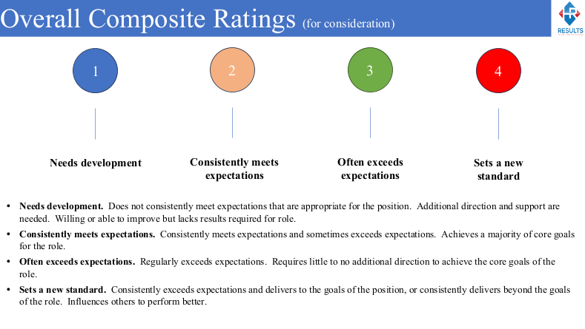
How many ratings do you all want 3, 4 or 5?
2 people think a 3 rating
17 people think a 4 rating
5 people think the 5 rating
Kim McFee – “Is there going to be a N/A, because we have that on our current evaluations?”
Kim Legg – “I don’t think you should have a N/A. You could add one saying “too soon to rate”, that would be for new employees that haven’t been there long enough.”
Martha Lesson – “2 & 3 seem redundant to me. They are almost the same”

Weightings
How much weight are given to each area – Goal achievement and Competencies.
Autumn Bender – “That’s where I think it gets different for each department.”
Brooke Buchanan – “I agree with that, because where I work and where Autumn work are completely different. And her goal achievement and mine don’t carry the same weight the same with the competencies.”

Kim Legg – “I would like to have a sub-set of the staff council to work together on this initiative, and get some ideas and maybe each department devise a “weightings” so that we can either have it separate or synthesize something for the whole. And after I get back with the leadership team we can come up with a plan to move forward.”
Kim McFee – “I think this was very informative and very helpful to us in setting the next step to getting this evaluation process completed.”
Applause for Kim Legg!

Brent Dotson – Thanks Kim Legg.
Martha Lesson needs to step down as ACCE rep. We need to get volunteers or nominations for the ACCE rep at this time.
Elizabeth Knick nominates Melissa Graham.
Melissa accepts.

Motion to adjourn – Cyndi Dotson
2nd by Elizabeth Knick

Meeting adjourned!

