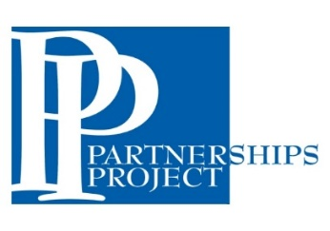

2021-2022 WVUP PROFESSIONAL DEVELOPMENT SCHOOLS

PROJECT PROPOSAL FORM

Up to $500.00 (or request)

Deadline is December 15, 2021 (initial distribution)
Deadline is April 1, 2022 (secondary distribution)

This simple form is the only requirement. You are also welcome to attach any additional information that would help us better evaluate your request.

School Name ________________________________________________________
Contact and Email Address_______________________________________________
Description of the project or activity and any materials/resources required and how it will positively affect student growth in reading and math (please be specific)

Budget Breakdown (include specific amounts for all expenses)

Principals Signature _______________________________________ Date ________________

Please send your request to bobbi.marshall@wvup.edu or WVUP Education Division,
ATTN: Bobbi Marshall, 300 Campus Drive, Parkersburg, WV 26104

QUESTIONS: Contact Bobbi Marshall at 304-424-8314 ex 442 or bobbi.marshall@wvup.edu

Awards distribution will depend on funds availability. Materials/equipment purchased will remain the possession of the PDS.

The funding for this project is presented with support from the West Virginia Department of Education.

