Teachers Test Prep offers $10,000 in Scholarships to Future Teachers
Teachers Test Prep, an education company that supports prospective teachers, is offering $10,000 through its 2019 Teachers Test Prep “Pass the Torch” Teacher Scholarships. Two $5,000 scholarships will be awarded: one to a student preparing to become an elementary school teacher and one to a student preparing to become a secondary school teacher. Unlike most scholarships, however, the money does not go toward tuition fees, but is instead intended for living expenses that financial aid typically does not cover.
“When I was at college, I had to work—often full-time—in order to pay for rent and food,” Teachers Test Prep founder Robert Duncan explains. “Becoming a credentialed teacher involves a lot of study and preparation, yet many students are trying to juggle both their coursework and a job just so they can get by. We hope these scholarships will help alleviate this pressure, allowing recipients to focus more of their time and energy on becoming effective teachers.”
To qualify for the scholarships, students must be enrolled in a US teacher preparation program and be receiving Federal Student Aid or otherwise able to demonstrate financial need. Applicants are asked to submit a video telling the story of a teacher who had an impact on them and explaining what they learned from this teacher that they would like to pass on to their future students.
For more information or to apply, visit: https://www.teacherstestprep.com/teacher-scholarships
About Teachers Test Prep
Teachers Test Prep is the nationwide leader in teacher credentialing exam preparation, serving over 250,000 individual users and partnering with top universities and school districts. Services include free online practice tests, online prep programs using instructional videos, one-on-one tutoring and in-person prep classes. Exams include Praxis, CSET, CBEST, CPACE, RICA and FTCE.
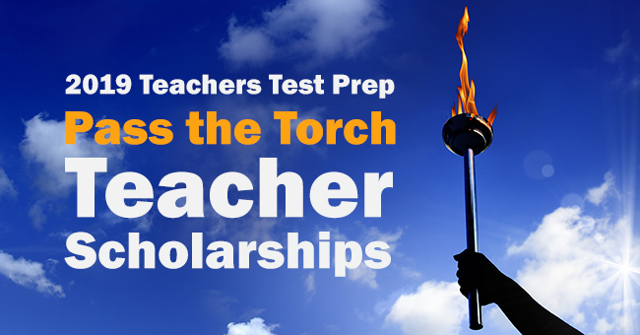 IMAGE: Scholarship Program Logo
IMAGE: 2018 Scholarship Finalists

